Chapter 19, Solution 77.

We follow Example 19.15 except that this is an AC circuit.

(a) We set V₂ = 0 and I₁ = 1 A. The schematic is shown below. In the AC Sweep Box, set Total Pts = 1, Start Freq = 0.1592, and End Freq = 0.1592. After simulation, the output file includes

FREQ IM(V_PRINT2) IP(V_PRINT2)

1.592 E–01 3.163 E–.01 –1.616 E+02

FREQ VM($N_0001) VP($N_0001)

1.592 E–01 9.488 E–01 –1.616 E+02

From this we obtain

h₁₁ = V₁/1 = 0.9488∠–161.6°

h₂₁ = I₂/1 = 0.3163∠–161.6°.

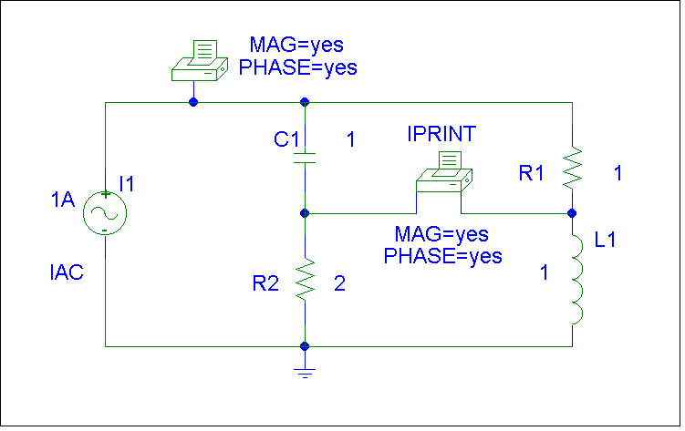

(b) In this case, we set I₁ = 0 and V₂ = 1V. The schematic is shown below. In the AC Sweep box, we set Total Pts = 1, Start Freq = 0.1592, and End Freq = 0.1592. After simulation, we obtain an output file which includes

FREQ VM($N_0001) VP($N_0001)

1.592 E–01 3.163 E–.01 1.842 E+01

FREQ IM(V_PRINT2) IP(V_PRINT2)

1.592 E–01 9.488 E–01 –1.616 E+02

From this,
h₁₂ = V₁/1 = 0.3163∠18.42°

h₂₁ = I₂/1 = 0.9488∠–161.6°.

Thus, [h] =

